1.sd and variance:-

avgspeed=c(78,81,82,74,83,82,77)

ttime=c(39,37,36,42,35,36,40)

sd(avgspeed)

sd(ttime)

var(avgspeed)

var(ttime)

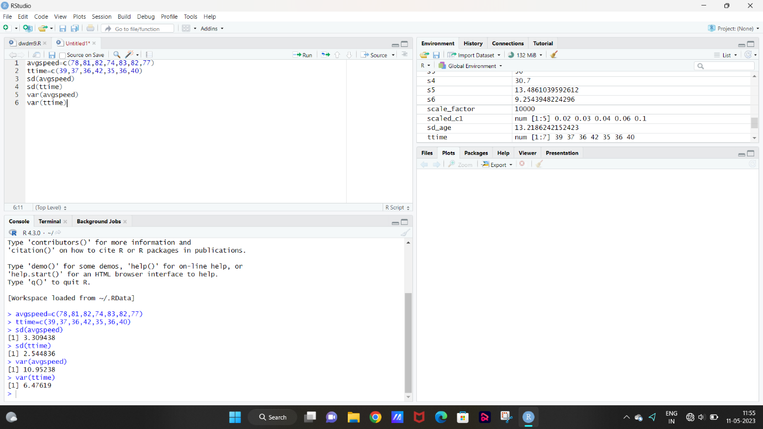

2.scatter:-

v1=read.csv("C:/Users/shail/Downloads/cancer.csv")

v2=scatter.smooth(v1$tumour.size)

v3=boxplot(v1)

v4=hist(v1$age)

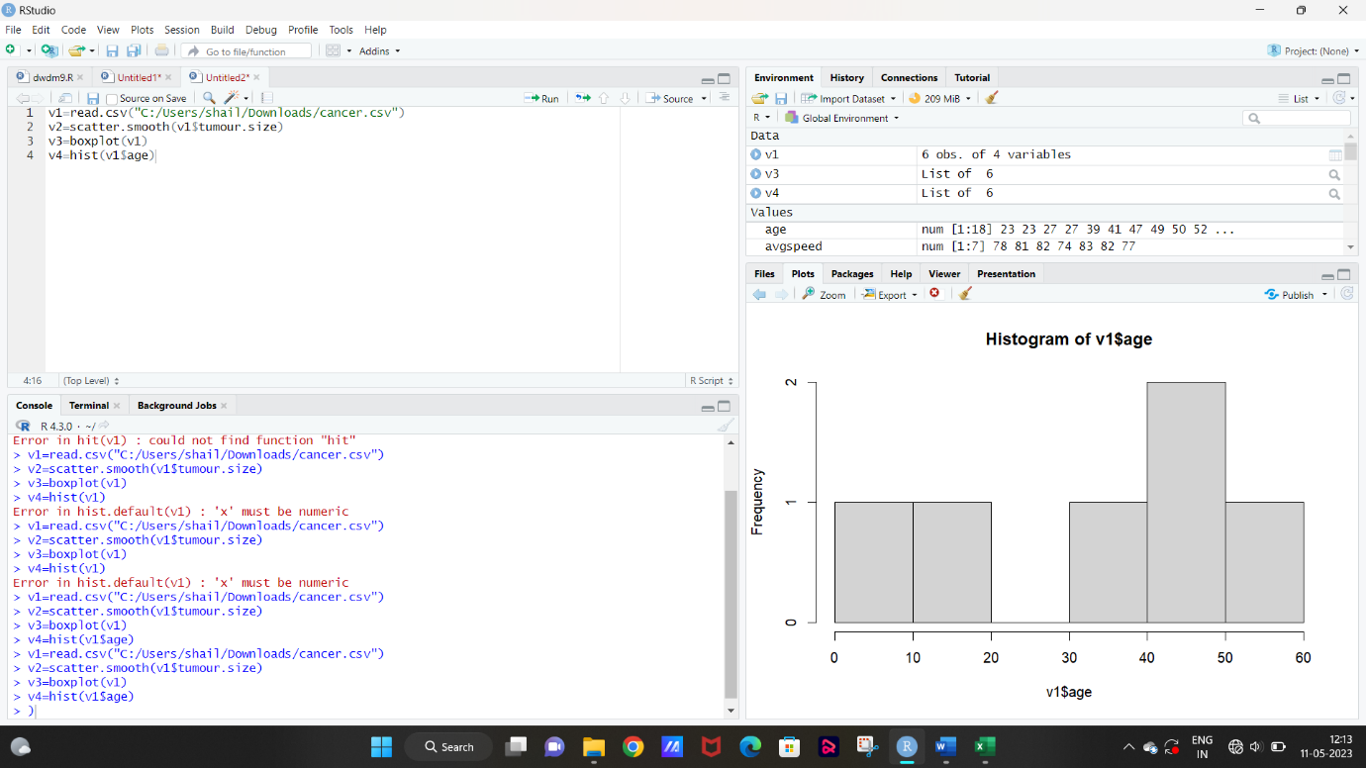

3.

true_apples <- 9

true_strawberries <- 10

correct_apples <- 6

correct_strawberries <- 8

misclassified_apples <- 3

misclassified_strawberries <- 2

total_identified <- correct_apples + correct_strawberries + misclassified_apples + misclassified_strawberries

accuracy_apples <- correct_apples / true_apples

accuracy_strawberries <- correct_strawberries / true_strawberries

precision_apples <- correct_apples / (correct_apples + misclassified_strawberries)

precision_strawberries <- correct_strawberries / (correct_strawberries + misclassified_apples)

recall_apples <- correct_apples / true_apples

recall_strawberries <- correct_strawberries / true_strawberries

cat("total identified fruits:", total_identified, "\n")

cat("accuracy for apples:", round(accuracy_apples, 2), "\n")

cat("accuracy for strawberries:", round(accuracy_strawberries, 2), "\n")

cat("precision for apples:", round(precision_apples, 2), "\n")

cat("precision for strawberries:", round(precision_strawberries, 2), "\n")

cat("recall for apples:", round(recall_apples, 2), "\n")

cat("recall for strawberries:", round(recall_strawberries, 2), "\n")

